**CPSC 224 Final Project**

**PROJECT PLAN**

**11/8/24**

**Blackjack**

**Git Good**

**<Insert Team Logo (if you have one)>**

**Prepared by:**

____Parker Shore__________________ _____Tyler Yasukochi_______________

<Put Student 1 Name Here> <Put Student 2 Name Here>

____Jonathan Courter_____________ ______________________________

<Put Student 3 Name Here> <Put Student 4 Name Here>

**1 Project Overview**

**1.1 Project Summary**

What game are you making? Include a short description of the game (look it up on Wikipedia, etc). An image of the official game would be helpful to orient the reader to what game you're making. How many players are there? Is it a dice, cards, board, or other game pieces kind of game?

We will be making a program to run and play blackjack. It is a card game where each player gets dealt cards. It is a “push your luck” type of game where each player will aim to draw as many cards as they can without getting over 21 total points worth of cards. It can be played with 1 – 4 players, and the dealer is controlled by a CPU. Players can gamble money on if they score higher than the dealer.

**2 Project Requirements**

**2.1 Major Features**

Provide a description of the major features that must be implemented for a viable and useful product. Major features include broad feature areas, constraints that must be met, and other major items that must be completed for the project to be considered successful. You should have at least 4-5 major features.

**Table 1: Major Features**

|  |  |
| --- | --- |
| *Feature* | *Description* |
| *Cards* | There is a deck of cards that will be distributed to the dealer and each player. |
| *Player* | Each player will have a hand with a score, and their own balance. |
| *Dealer* | The “dealer” will have their own hand and be the benchmark that players try to beat. |
| *GUI* | The game will be played on a GUI that cleanly presents the user with what they can do during the game and all the information they need. |
| ... | ... |

**3 Project Game Design**

**3.1 Initial User Interface Design**

Provide a description of the general user interface layout, including a set of initial user interface design mock-ups. This can be done as a sketch if it's cleanly done by hand, or digitally using a drawing tool.

**3.2 Initial Software Architecture**

Provide a description of the initial architecture of your application, focusing on the major components of your system and how they will interact. This should include a UML class diagram and 2-3 sequence diagrams of the various modules in the system interacting.

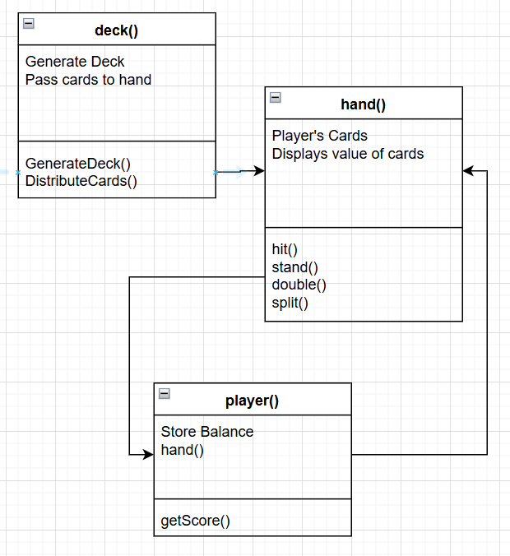

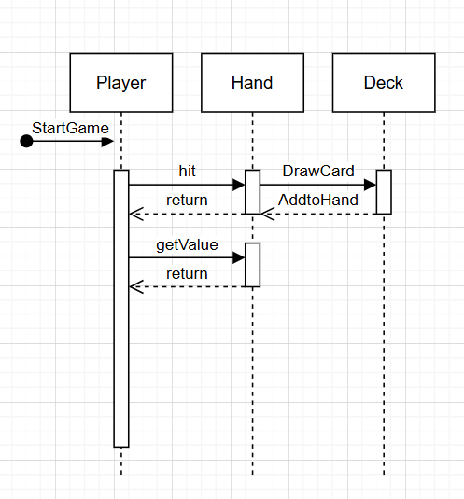

There will be a generic player class. Each player has their own class that inherits from this generic class. Each player has their own balance. There will be a dealer class that also extends from the generic class and is handled different than the players. Then there will be a hand class that extends from the player and dealer class that stores what cards a player currently has and calculates the score of their hand. There will also be a deck that stores cards, which have a value and a suit. The cards will be moved around to the players and dealer.

**4 Project Schedule**

Provide a description of the major scheduling dates of your project. For each schedule milestone dates, clearly describe the milestone (e.g., what features will be implemented) and when the milestone must occur by. Include the project plan, code complete, presentation, and final report dates.

**Table 3: Major Scheduling Milestones**

|  |  |  |
| --- | --- | --- |
| *Milestone* | *Description* | *Target Completion Date* |
| *Project Plan done* | *Complete the document design and planning aspect, which includes milestones, project description, UML diagrams, and major features of the project.* | *November 9th* |
| *Basic Structure* | *Create the game loop and initialize all classes.* | *November 13th* |
| *Finish code outline/structure and foundation* | *We want to finish the rules, and foundation of the code before working on the GUI, which will take a long time because we are dealing with cards. Functional GUI that can run a basic version of the game and can be created alongside the game.* | *November 27th* |
| *Finish Coding/GUI Niceties* | *Work collaboratively to produce a complete and behaviorally accurate project in java. Implement the scoring of player hands* | *December 2nd* |
| *Project Presentation* | *Present work to class the week of December 2nd. Live demonstration and questions answered during this session.* | *Week of December 2nd* |
|  |  |  |

**Appendix**

Provide additional supplemental information in an appendix as necessary.